# 🧠 Mistral AI Content Generator (Flask App)

This project is a web-based content generator powered by **Mistral AI**. It allows users to generate:

* ✍️ Blog Posts
* 📢 Social Media Content
* 📧 Marketing Emails
* 📊 Slide-wise PowerPoint Presentations

## 🚀 Features

* Flask-based web interface
* Mistral AI-powered content generation
* Text output and .pptx export
* Supports multiple tones (professional, friendly, persuasive)
* Built-in preview/download functionality

## 🛠️ Technologies Used

* Python 3.10+
* Flask
* Mistral AI API
* python-dotenv
* python-pptx

## 📁 Project Structure

``` mistral-ai/ │ ├── app.py # Flask web server ├── mistral_content_creator.py # Core logic: text + ppt generation ├── templates/ │ └── index.html # HTML frontend ├── outputs/ # Generated files (auto-created) ├── .env # API Key (you create this) └── README.md # This file ```

## ⚙️ Setup Instructions

### 1. Clone the repo

```bash git clone https://github.com/your-username/mistral-ai-flask.git cd mistral-ai-flask ```

### 2. Install dependencies

```bash pip install flask python-dotenv python-pptx requests ```

### 3. Set your Mistral API Key

Create a file named .env in the root folder:

``` MISTRAL_API_KEY=your_actual_mistral_api_key_here ```

🔒 **Important:** Never share your .env publicly.

### 4. Run the app

#### ✅ Local (localhost)

```bash python app.py ```

Visit: <http://127.0.0.1:5000>

#### ✅ On Codeanywhere

Change in app.py: ```python app.run(host=‘0.0.0.0’, port=5000, debug=True) ```

Then use **Codeanywhere’s “Open Preview”** for port 5000.

## ✨ Usage

1. Enter a topic like: AI in Healthcare
2. Choose a content type:
   * blog → Text article
   * social → Tweets/LinkedIn posts
   * email → Short marketing email
   * ppt → Auto-generated PowerPoint content
3. Select tone: friendly, professional, or persuasive
4. Hit Submit
5. View or download the generated content!

## 📄 Example Output

* **Text (blog):** Saved as .txt in /outputs
* **PowerPoint:** Saved as .pptx in /outputs, downloadable

## 🧪 Sample Prompt for PPT

Topic: Generative AI in Education  
Type: ppt  
Tone: professional

## 📌 License

This project is for educational/demo use only. You must have access to [Mistral AI](https://mistral.ai/) to use the API.

## 🙋‍♀️ Author

Made with ❤️ by Lasya

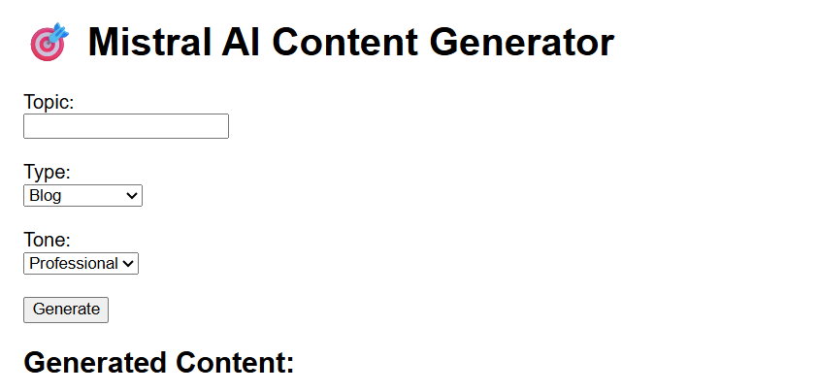

Note: ppt as well as text can be generated

Ppt can be downloaded